

National University of Computer & Emerging Sciences, Karachi
Artificial Intelligence-School of Computing
Fall 2023, Lab Manual – 01- Installation Guide
Course Code: CL-2005 | Course: Database Systems Lab
Instructor(s): | Sohail Ahmed Malik, Mr. Mubashir, Mr. Sameer Faisal, Ms. Mehak Mazhar, Ms, Fatima, Ms. Mahnoor Javed, Ms, Filza Akhlaq, Ms. Bushra Sattar, Ms. Ravia Ejaz, Ms. Yumna Asif

Contents:
1. Installation

Installation
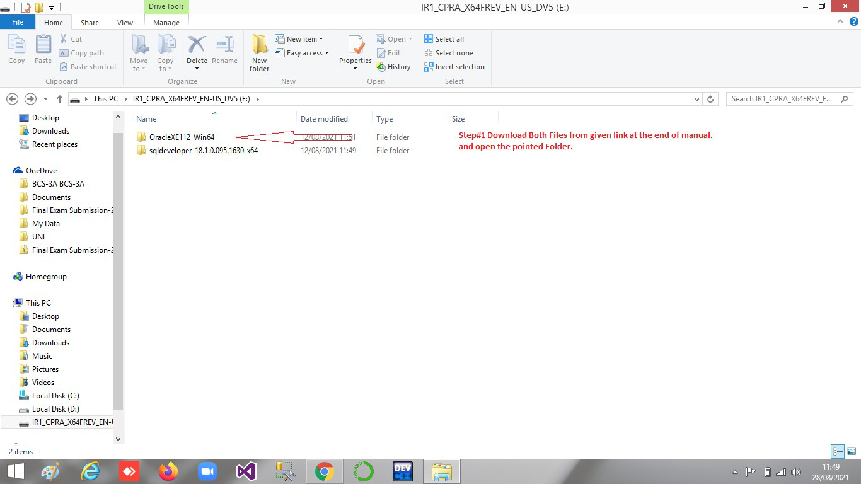
Step#01

Step#02
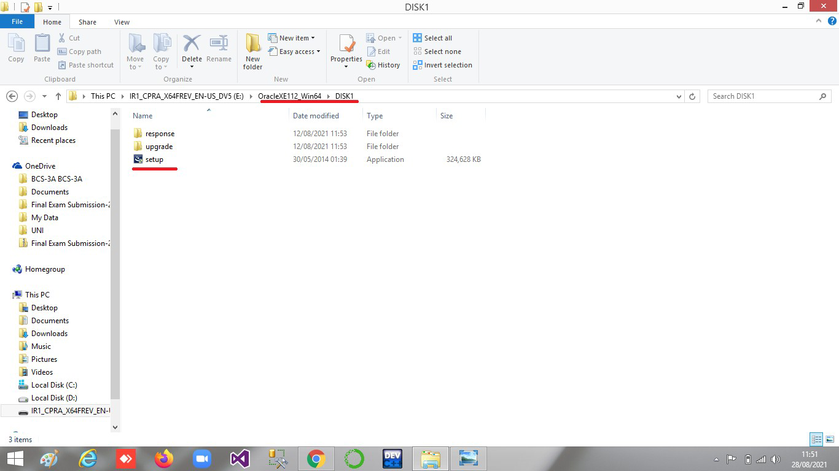

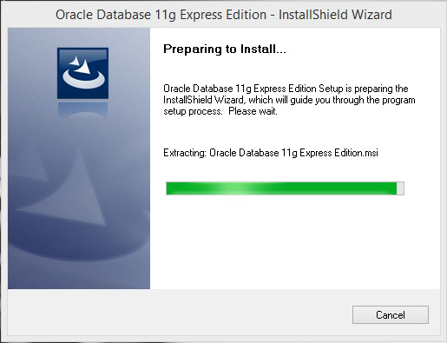
Step#03

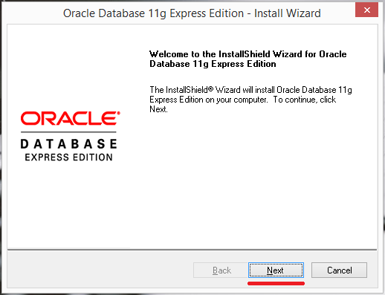
Step#04

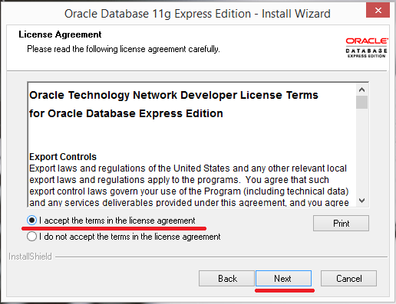
Step#05

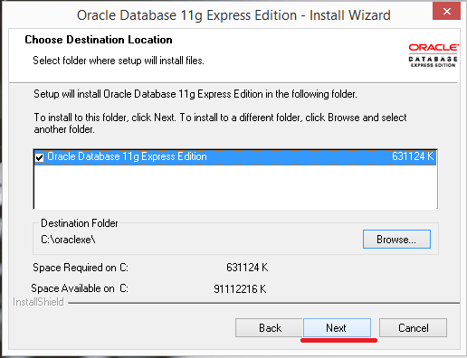
Step#06

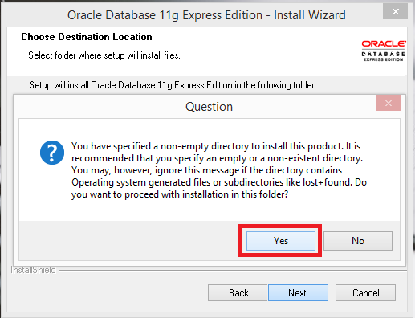
Step#07

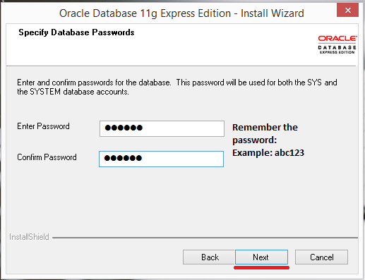
Step#08

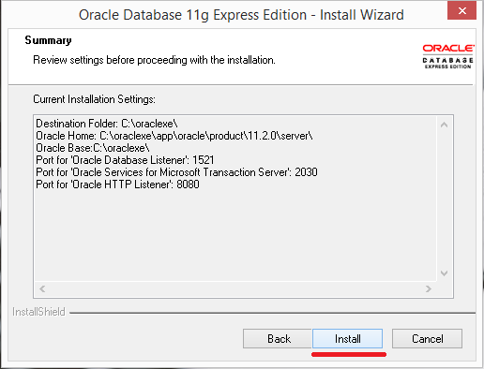
Step#09

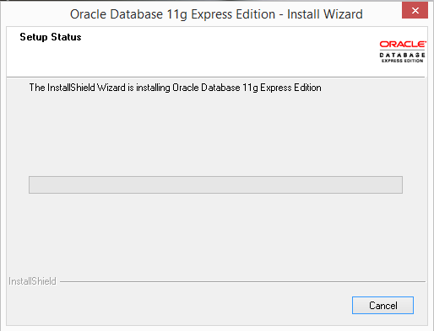
Step#10

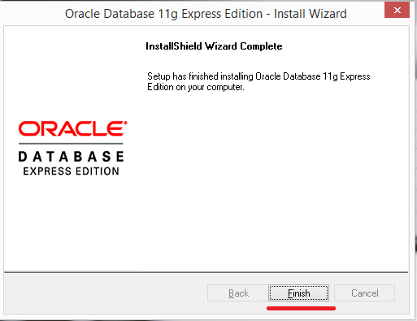
Step#11

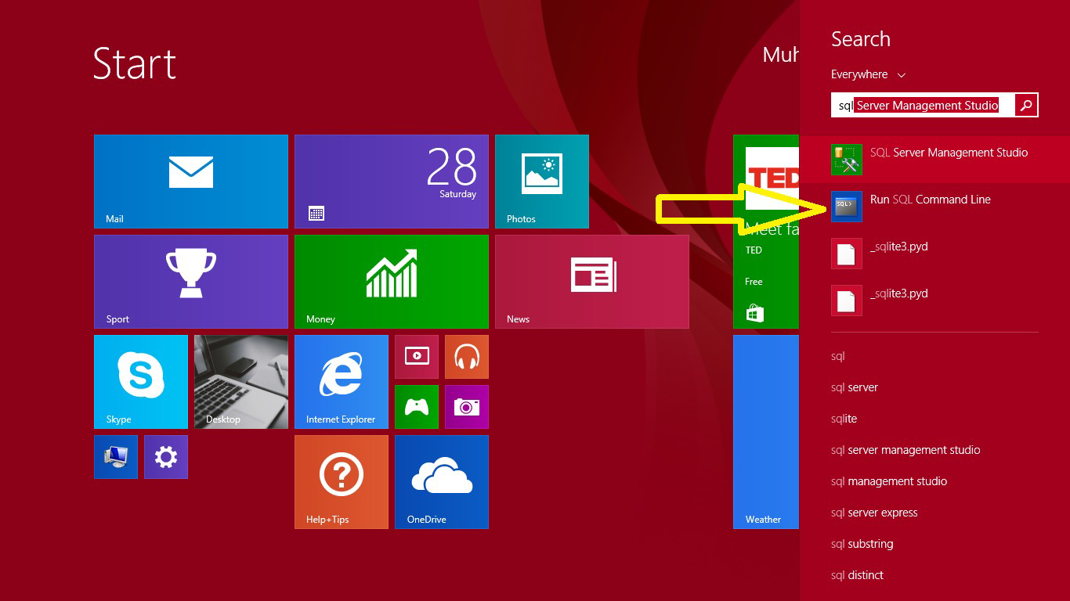
Step#12

Step#13
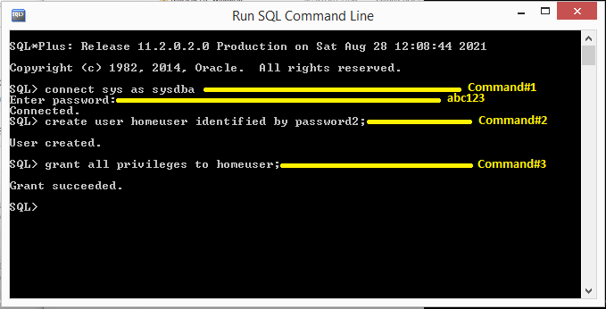

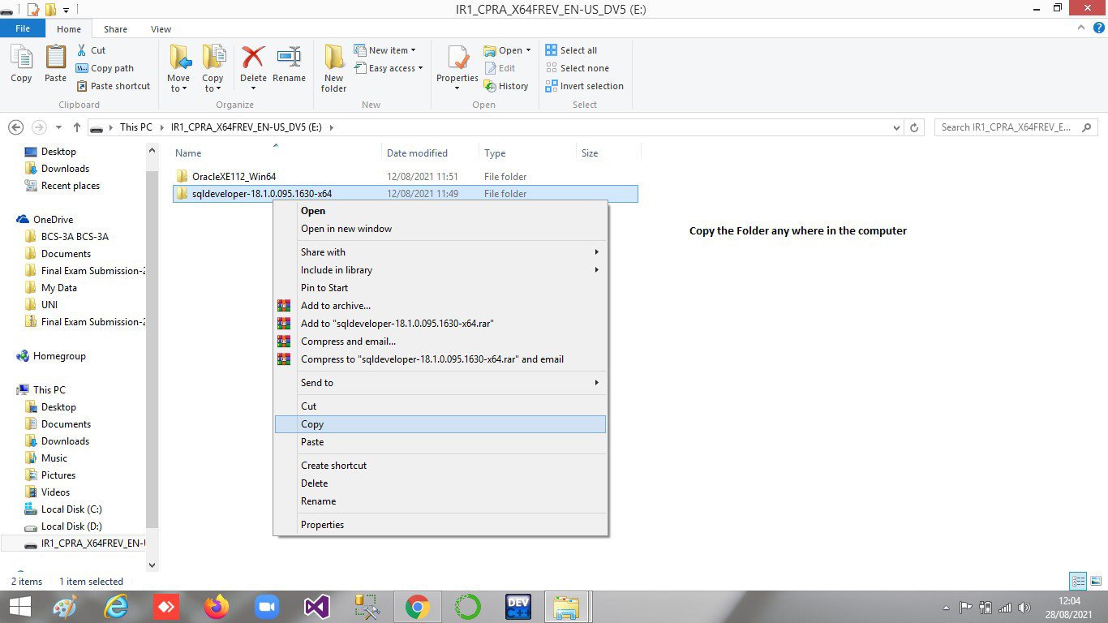
Step # 14
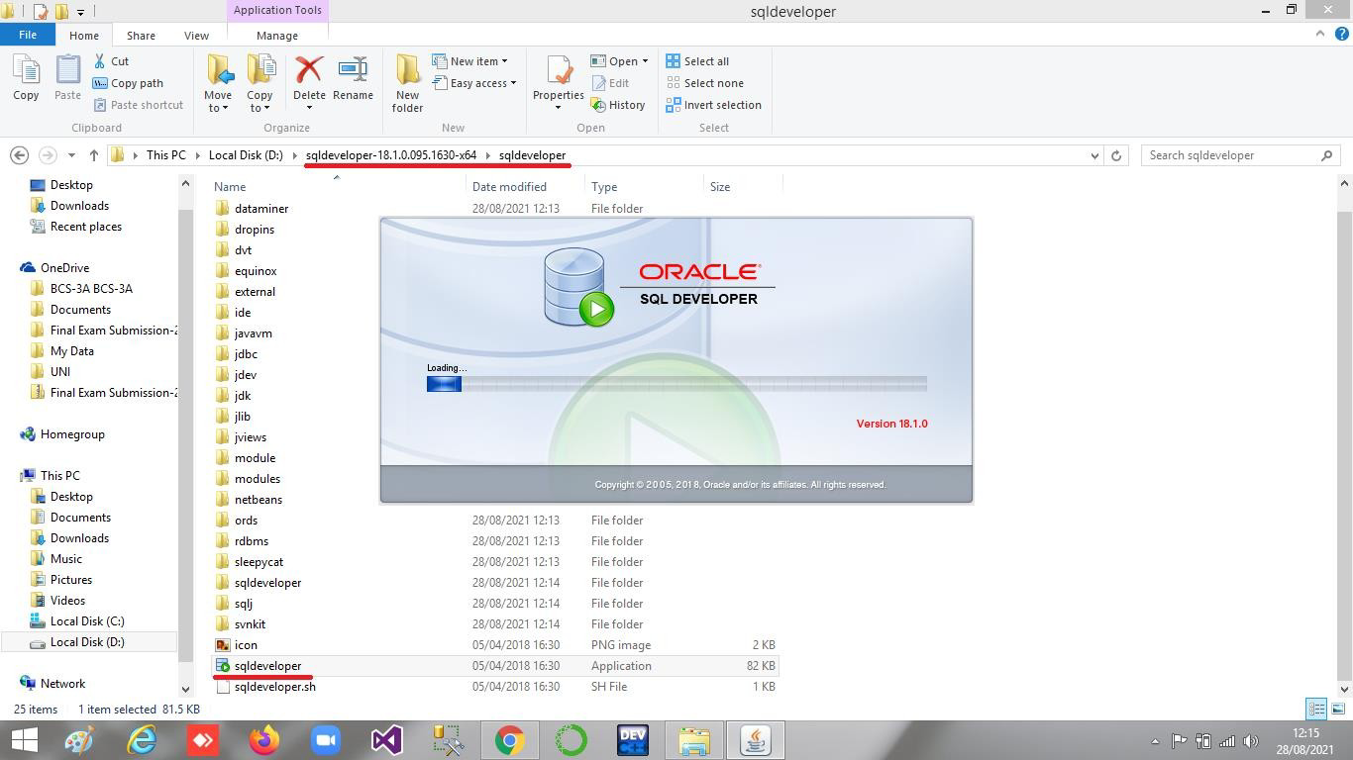
Step#15

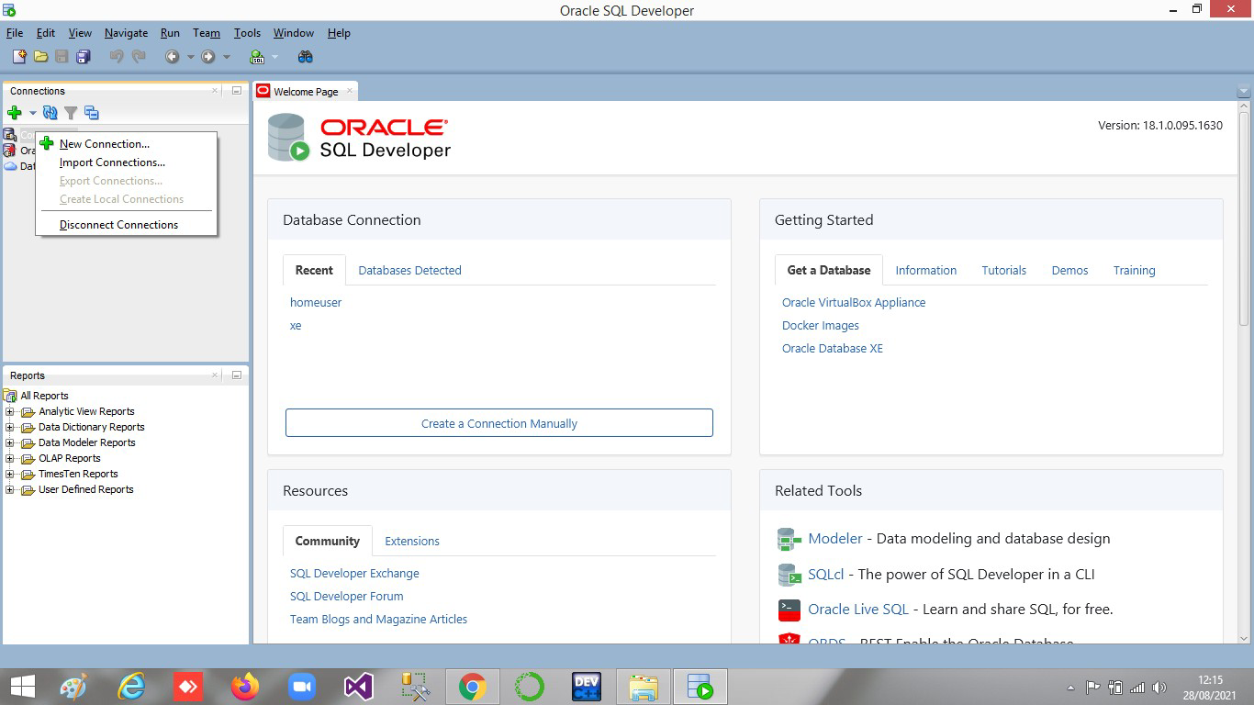
Step#16

Step#17
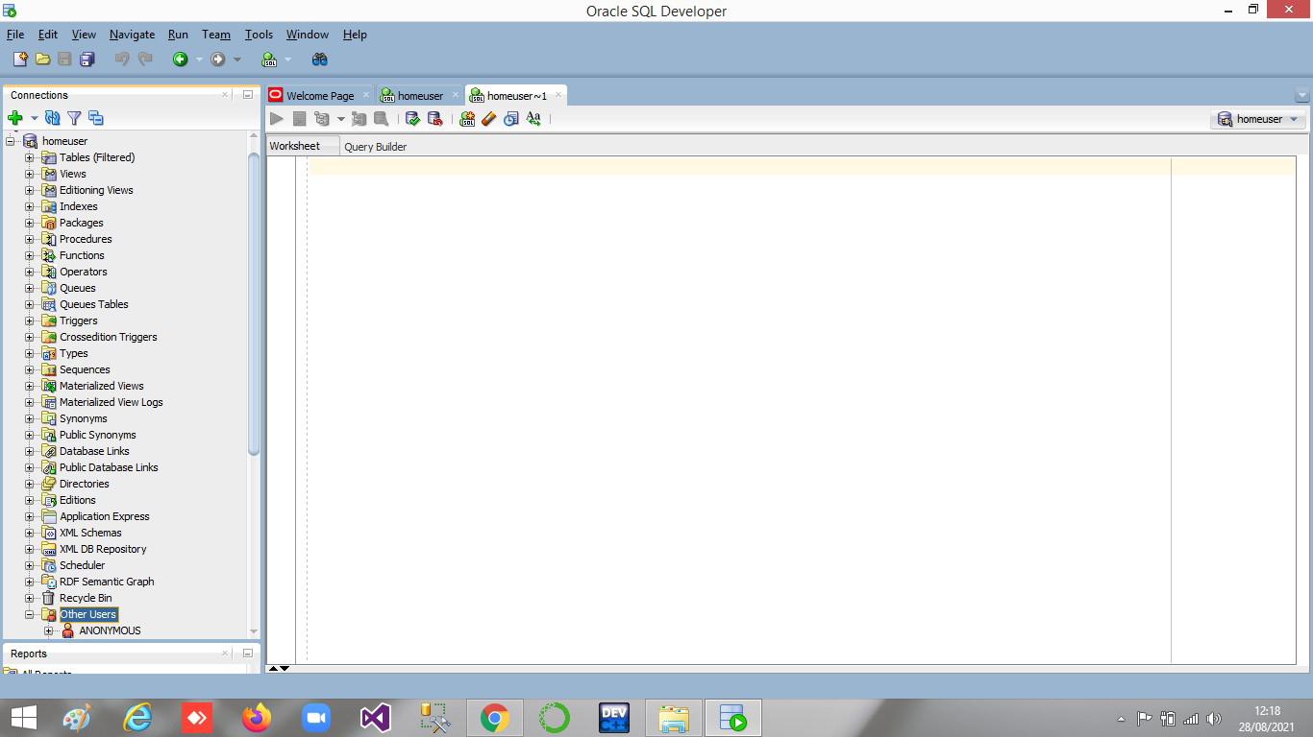

Step # 18
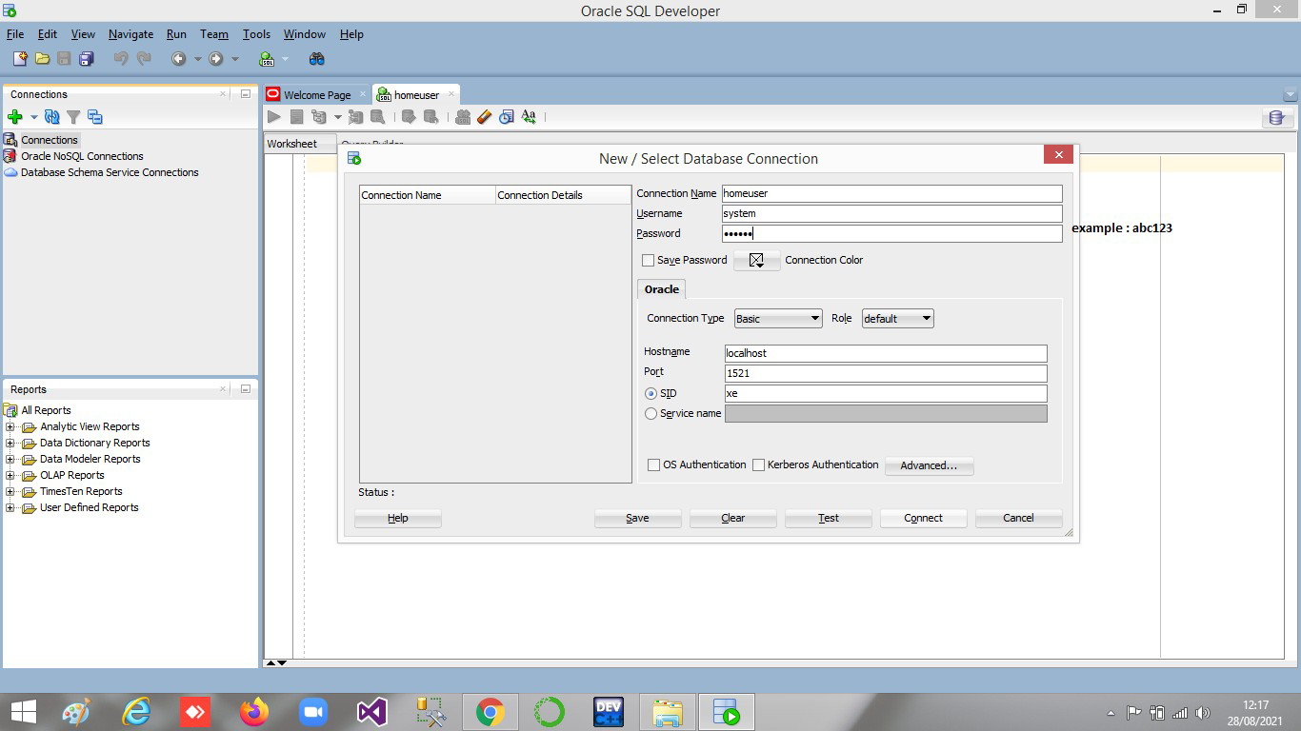
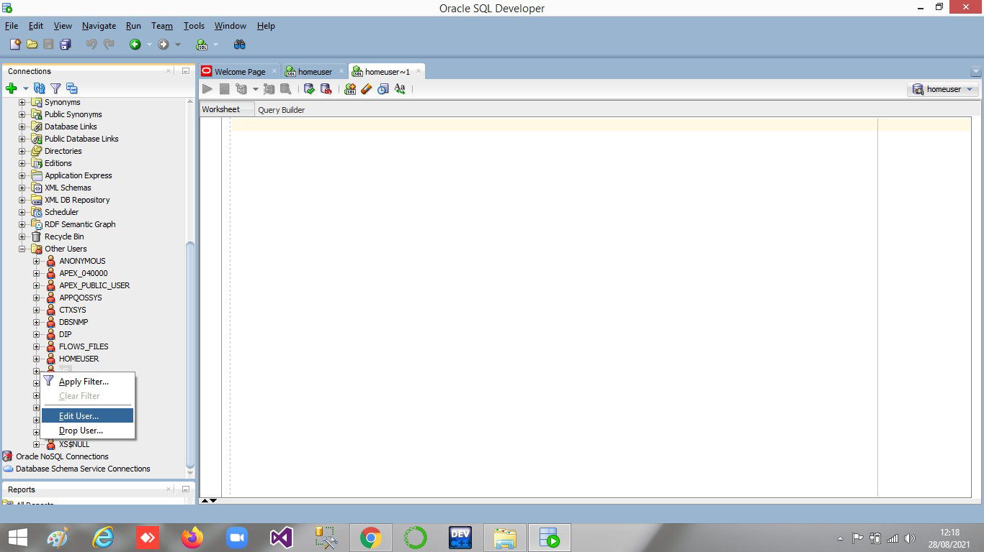
Step#19

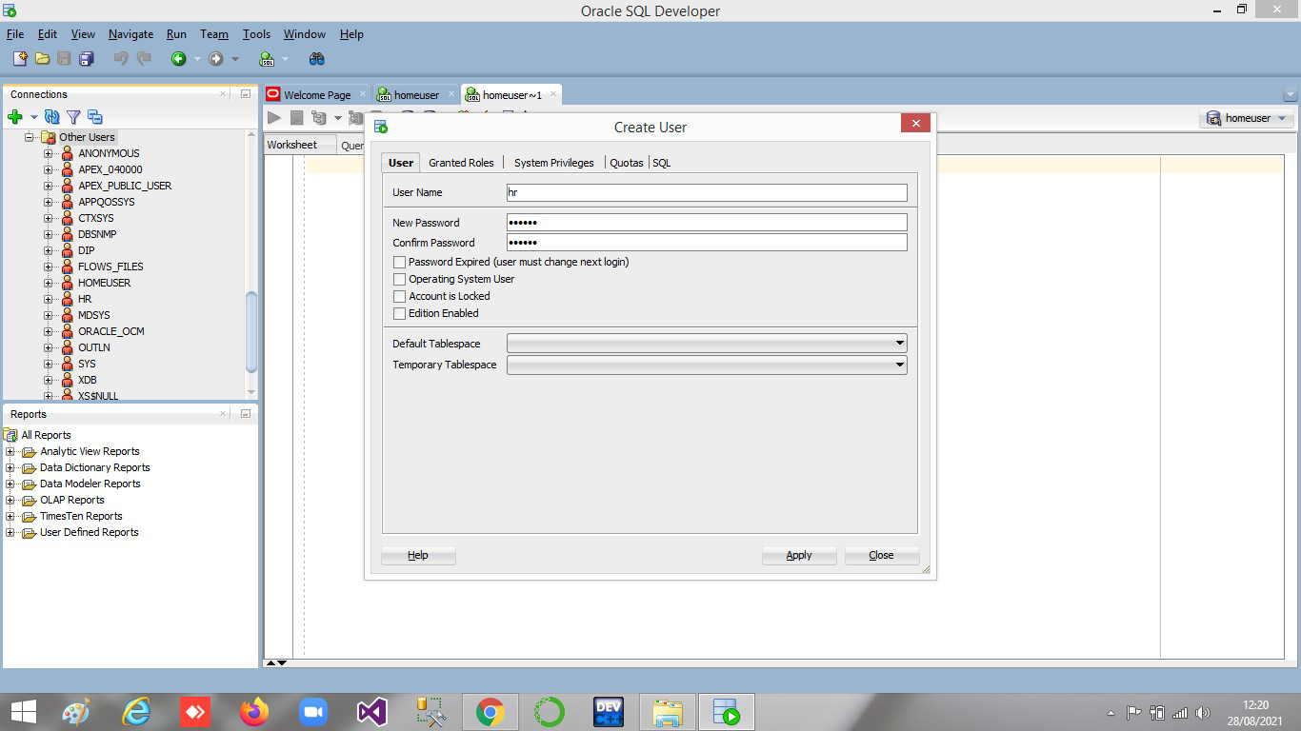
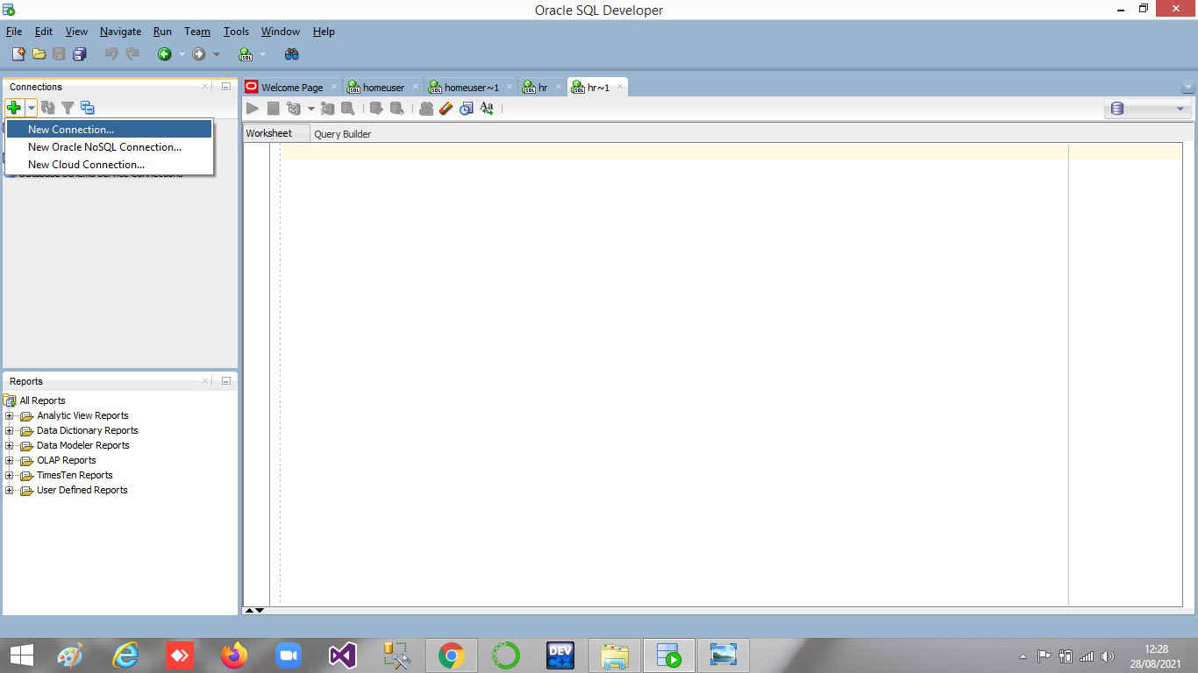
Step#21

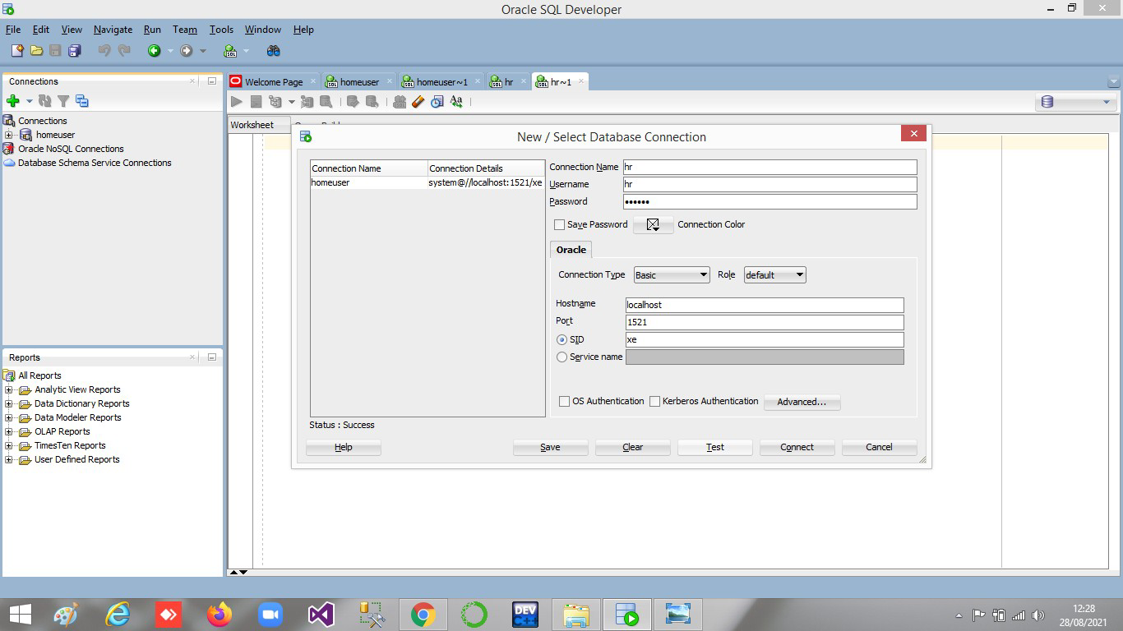
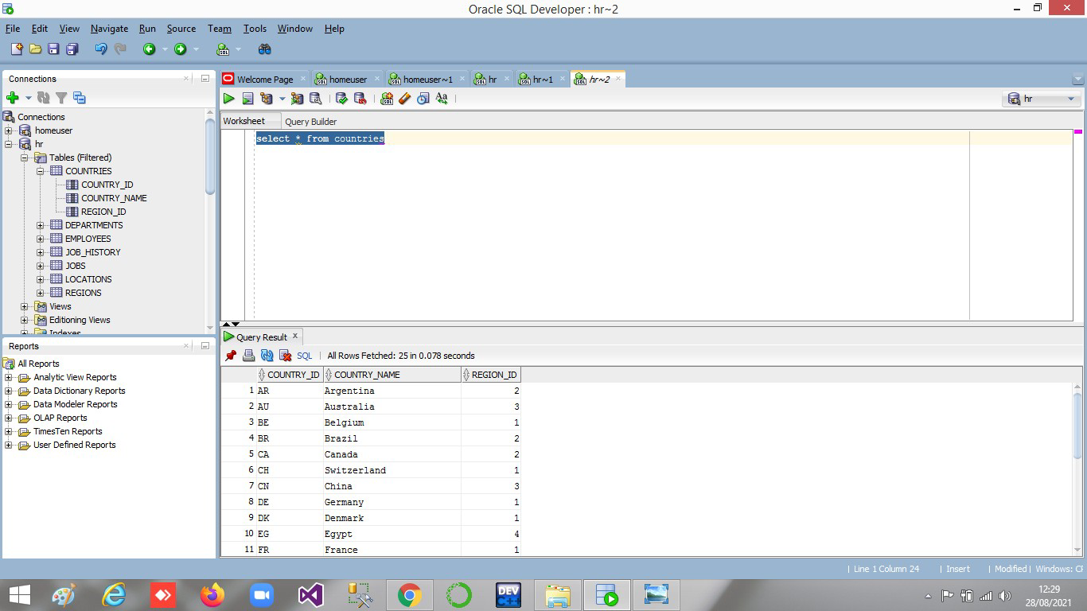
Step#23

Oracle & SqlDeveloper Download Link https://drive.google.com/drive/folders/1a2agl45zMwJIUHUSBmC1kc-S_nM19t_z?usp=sharing

-----------------------------END-----------------------------

